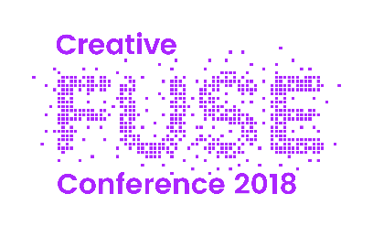

Workshop Application Form
Please fill in the following details and email your completed form to faye.harland@ncl.ac.uk. Please ensure every section is filled in as incomplete forms will not be accepted. The closing date for applications is 16:00 on 21/5/18.
***
Workshop title:

Preferred number of attendees
- Minimum:
- Maximum:

Workshop host(s)’ name(s):

Contact email address for each workshop host:

Contact telephone number for each workshop host:

Workshop host(s)’ job title(s) and company/organisation(s):

A brief summary of your prior experience:

A short (500 words max) summary of what the workshop will involve and its outcomes:

The venue has guest wifi, a projector screen, speakers, roving microphones and lapel microphones. Please let us know if you require any equipment in addition to this as we have conference funds available to fulfil additional A/V needs.

